Curriculum Vitae
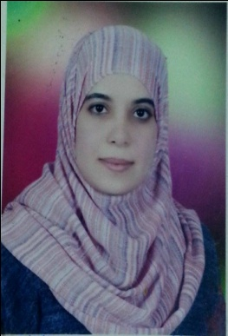
- Personal Data:
• Name: Sara Farrag Ahmed Mohamed
• Title: M.Sc. Degree Rheumatology and Rehabilitation
• Current Position: Assistant lecturer of Rheumatology and Rehabilitation, Assuit 2012-till now University Hospitals, Egypt.
• Previous position:
- Demonstrator of Rheumatology and Rehabilitation, AssuitUniversity Hospitals, Egypt 2011-2012
- Resident doctor of Rheumatology and Rehabilitation, Assuit2009-2012University Hospitals, Egypt
- Trainer Doctor2008-2009, AssuitUniversity Hospitals, Egypt
• Gender: Female
• Marital status: Married and has one child
• Nationality: Egyptian
• Birth date: September 15th. 1984
• Place of birth: Assuit, Egypt
• Affiliation: Rheumatology and Rehabilitation Dept., Assiut University Hospitals, Assiut, Egypt
• E-mail: Haneen_hanan89@Yahoo.com
Sara_Farrag@aun.edu.eg

Cellular: +201097767735 - Fax: +20882333327 (Hospital Fax)
• Languages: English and Arabic.
• Major specialty: Internal Medicine
• Minor specialty: Rheumatology and Rehabilitation
• Current Home address: Assiut, Nile Khaton, Cars Insurance Street, Abdelsayed Masjed street, Assiut, Egypt.

B)Qualifications and degrees:
- General certificate of secondary education in 2001.
- MB.BCh., Bachelor degree of medicine and surgery, Assiut faculty ofmedicine, Egypt in 2007 with final grade (Excellent).
- M.Sc. of Rheumatology and Rehabilitation, Assiut University, Egypt in June 2012 with final grade of (very good).

C) Positions held:
a) Current: Assistant lecturer in Rheumatology and Rehabilitation Department, Assuit University.Hospitals, Egypt
b) Past:
- House officer for one year -rotatory- in Assuit University hosp., Egypt.
- Resident doctor Rheumatology and Rehabilitation, Assuit University hospitals, Egypt.
- Demonstrator Rheumatology and Rehabilitation division, Assuit University hospitals, Egypt.

D) Scientific activities:
- Teaching clinical and theoretical Rheumatology and Rehabilitation medicine for medical students in Assiut University, Assiut, Egypt.
- Supervision of the scientific and clinical performance of junior residents and house officers.
- Attending and participating in organizing national scientific meetings and conferences regularly in Egypt.
- Master thesis entitled Recent Advances in Lupus Nephritis.
- MD thesis entitled Osteoprotegerin Gene Polymorphism (Tumor Necrosis Factor Receptor Super family 11B (TNFRSF11B)) and Atherosclerosis In Egyptian Patients with Rheumatoid Arthritis.

F) Society membership:
1- Member of the Egyptian Society of Rheumatic Diseases.

Dr. Sara Farrag Ahmed, M.Sc.
Assistant lecturer of Rheumatology and Rehabilitation
Assiut, Egypt

